# **24. DYNAMIC ROUTING**

### **What Is Dynamic Routing?**

Dynamic routing involves configuring a **dynamic routing protocol** on a **Layer 3 device (router)** to automatically determine the best routes to destination networks. Unlike static routing, dynamic routes can adapt to changes in the network.

Key characteristics:

* Routes are not fixed and adjust dynamically.
* Routers exchange route information with neighbors to maintain up-to-date routing tables.

#### **Key Terms:**

💡 **Network Route**: A route to a network or subnet (mask length < /32).

* Example: 10.0.12.0/30, 10.0.13.0/30

💡 **Host Route**: A route to a specific host (mask length = /32).

* Example: 10.0.12.1/32, 10.0.13.1/32

Host routes are automatically added to a router's interfaces for connected networks.

### **How Does Dynamic Routing Work?**

Dynamic routing protocols allow routers to **advertise network routes** to their neighbors. Routers update their routing tables dynamically as networks are added or removed.

#### **Example:**

1. **Route Advertisement**: R4 advertises its network to R2, which passes it to R1 and R3.
2. **Route Removal**: If the network on R4 becomes unavailable, the route is dynamically removed from all routing tables.

**Static Routing Limitation**:  
 In static routing, a downed route remains in the table, causing traffic to be sent to an unavailable network.

**Dynamic Routing Advantage**:  
 Dynamic routing can automatically reroute traffic through alternative paths if redundancy is configured.

#### **Example of Redundancy:**

Adding a second link between R3 and R4 creates an alternative path. If the primary route via R2 fails, traffic will be rerouted via R3.

💡 **Cost Factor**:  
 Dynamic routing protocols use a metric (e.g., cost, bandwidth, or delay) to determine the preferred path. This is similar to how spanning-tree protocols operate for switches.

### **Dynamic Routing Protocols**

Dynamic routing protocols enable routers to:

1. Advertise information about known routes.
2. Form neighbor relationships with adjacent routers.
3. Decide the best route based on metrics (lower metric = better route).

#### **Types of Routing Protocols:**

1. **IGP (Interior Gateway Protocol)**: Shares routes within a single autonomous system (AS).
   * Examples: OSPF, EIGRP, RIP
2. **EGP (Exterior Gateway Protocol)**: Shares routes between different autonomous systems.
   * Example: BGP

#### **Protocol Algorithms:**

Each protocol uses a specific algorithm to calculate the best route:

* **Distance Vector Protocols(Routing by Rumor)**: Routes by sharing only the distance (metric) and vector (direction/next hop). Examples: RIP, EIGRP.
* **Link-State Protocols**: Builds a complete map of the network for route calculation. Examples: OSPF, IS-IS.

### **Metrics in Dynamic Routing Protocols**

The **metric** determines the best route when multiple paths exist. Each protocol uses different metrics:

* **RIP**: Hop count. -> Worst
* **EIGRP**: Bandwidth and delay.
* **OSPF**: Cost (based on link bandwidth).

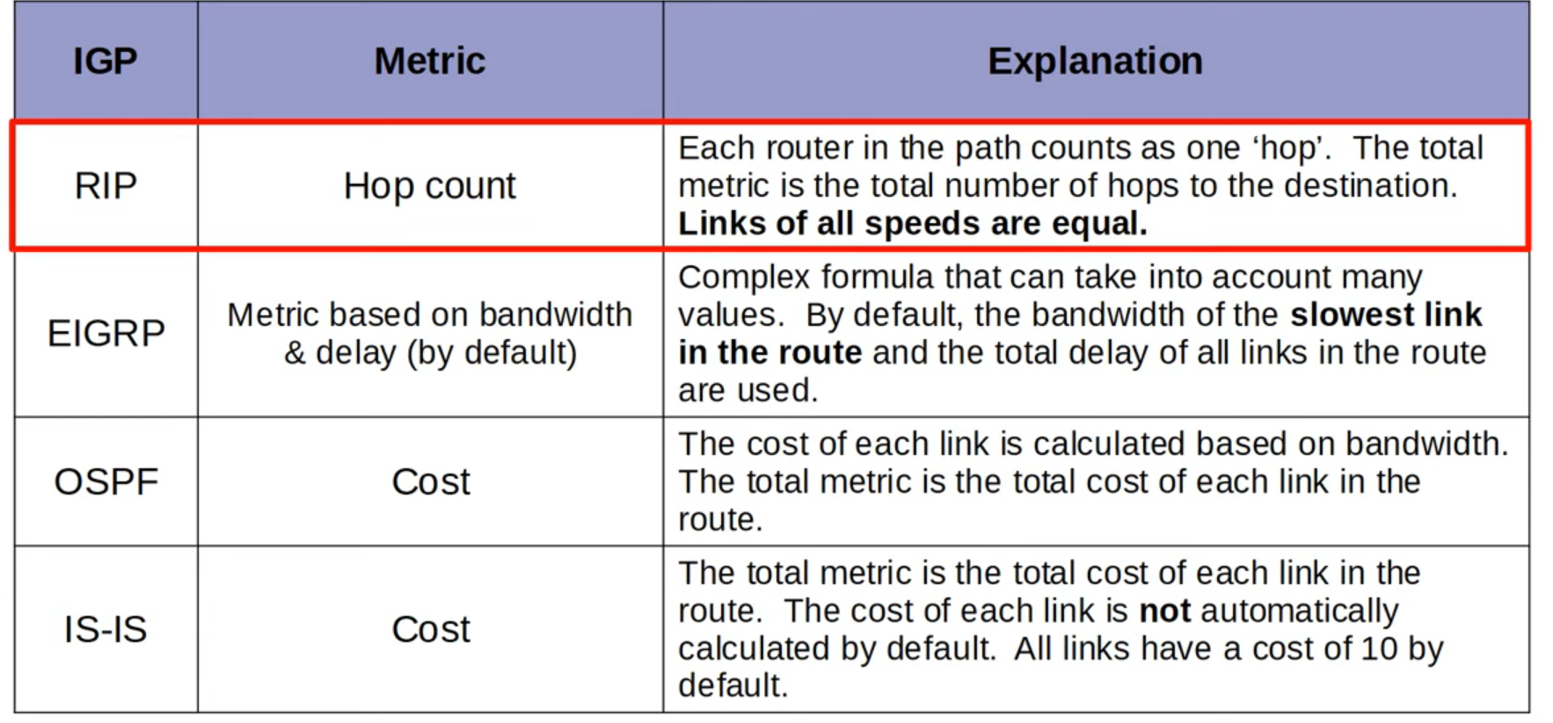

#### **Equal Cost Multi-Path (ECMP):**

If two routes to the same destination have the same metric, both are added to the routing table, and traffic is load-balanced across them.

### **Administrative Distance (AD)**

When routes are learned from multiple protocols, **Administrative Distance (AD)** determines the preferred source.

* Lower AD = Higher trustworthiness.
* Default AD values (must memorize for CCNA):
  + Directly connected: 0
  + OSPF: 110
  + EIGRP: 90
  + RIP: 120
  + External BGP: 20

💡 If the AD is 255, the route is not trusted and is not added to the routing table.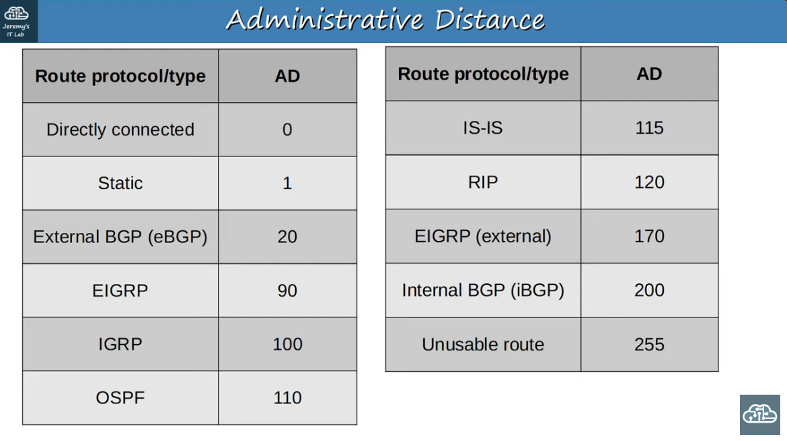

#### **Example:**

If OSPF and RIP both advertise a route to the same destination:

* OSPF is chosen (lower AD = 110 vs. 120).

### **Floating Static Routes**

A **floating static route** has an AD higher than the dynamic protocol’s AD, making it less preferred. It acts as a backup route and becomes active only if the dynamic route fails.

### **Link-State Routing Protocols**

* Routers create a complete network map by sharing detailed link-state information.
* Use more resources (e.g., CPU, memory).
* React faster to network changes than distance vector protocols.

### **Summary of Key Points:**

1. **Dynamic Routing**: Adapts automatically to network changes.
2. **Protocols**: Use metrics to determine the best route.
3. **Administrative Distance**: Decides route preference between protocols.
4. **Redundancy**: Ensures high availability in the network.

Trace route: Every hop sends a message back to the source

